**3 points will be subtracted from your overall grade each time you speak English in class.**

**You must speak only Spanish in class**

**Going to miss class?**

Since speaking and listening in class is a big part of your grade, you must make up absences within two weeks during our conversation group day. **Even excused absences must be made up.** When absent a ZERO will be added to your grades; after 2 weeks the zero will become permanent.

This course is equivalent to a third year college course in Advanced Spanish language skills. We speak exclusively Spanish and use authentic materials from many countries. A significant portion of the course prepares students to speak and write on academic topics. Among the topics we will examine include: how changes in technology may help or hurt people, a debate on climate change and other environmental issues, the do´s and don´ts of dating in other countries, the roots of our own identity, traditional and contemporary gender roles, architecture and what it tells us about a place, the struggle of migrant farmworkers in the US, celebrations throughout the Spanish-speaking world, indigenous approaches to health care, endangered species, regional dialects and many more topics. The full syllabus submitted to the College Board is eleven pages long; if you are curious you can download the whole thing from our edmodo class page!

**The answer to your question is YES because…**

OMG, everybody in this class already speaks Spanish. Am I in the right place?

I already speak Spanish perfectly at home. Should I even bother taking this class?

**EspañolAP AP**

[](http://www.google.com/url?sa=i&rct=j&q=&esrc=s&frm=1&source=images&cd=&cad=rja&docid=jaZMxv-r3BDj2M&tbnid=f45nBzP1j5al6M:&ved=0CAUQjRw&url=http://www.goodreads.com/book/show/4268157-perfect-chemistry&ei=bi4DUoCOI9TyyAH044EQ&psig=AFQjCNFe9-c4mv8cndLEuHjhIYdZKWeuqQ&ust=1376026511816174)

[](http://www.google.com/url?sa=i&source=images&cd=&cad=rja&docid=1MWsjhgl2cS4qM&tbnid=XXOSt_tzhSywmM:&ved=0CAgQjRwwAA&url=http://listas.rpp.com.pe/television/3125-el-actor-mexicano-mas-guapo&ei=NS0DUoSOGsPSiwK__YDwDw&psig=AFQjCNGjd0b2Tp9AmWtyH0Pd1wQthYLhvA&ust=1376026293474493)

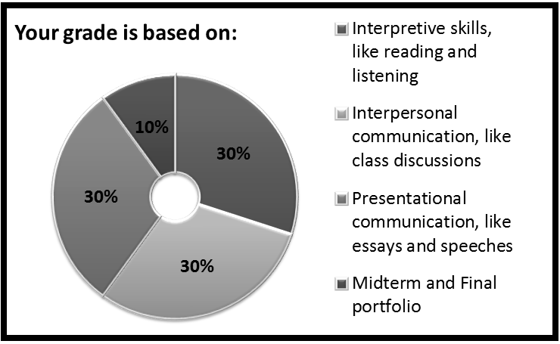

What does a normal AP unit look like?

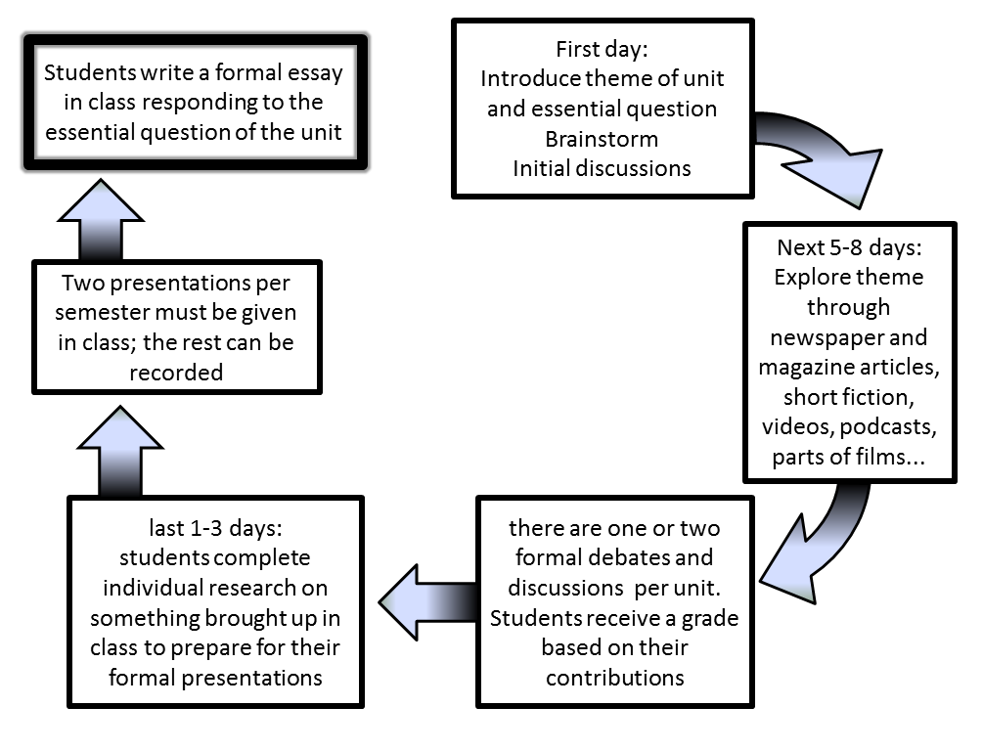



[](http://www.google.com/url?sa=i&rct=j&q=&esrc=s&frm=1&source=images&cd=&cad=rja&docid=863hK-5h_q0DSM&tbnid=bz-WX8scz_f8iM:&ved=0CAUQjRw&url=http://www.respuestario.com/como/como-aprender-a-leer-rapido-consejos-para-principiantes&ei=NvkCUu2xGMmUiAKC74CQBQ&bvm=bv.50500085,d.cGE&psig=AFQjCNGBJmbmgCYWj9Rv2PDKwPh6pyGuRw&ust=1376012553169309)

*Expect to listen to podcasts at home 3-4 times per week*

*And expect to read at home every day*

What do you need to do NOW?

One notebook to keep at home as a reading-listening journal; pass it in at the end of the unit

**and get two notebooks**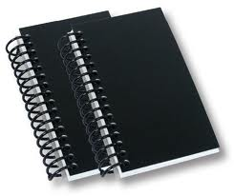

1. Go to our class web page for work and
2. Go to edmodo.com and join our class,

our group code is: 82c7dj

One notebook to bring to class

